A
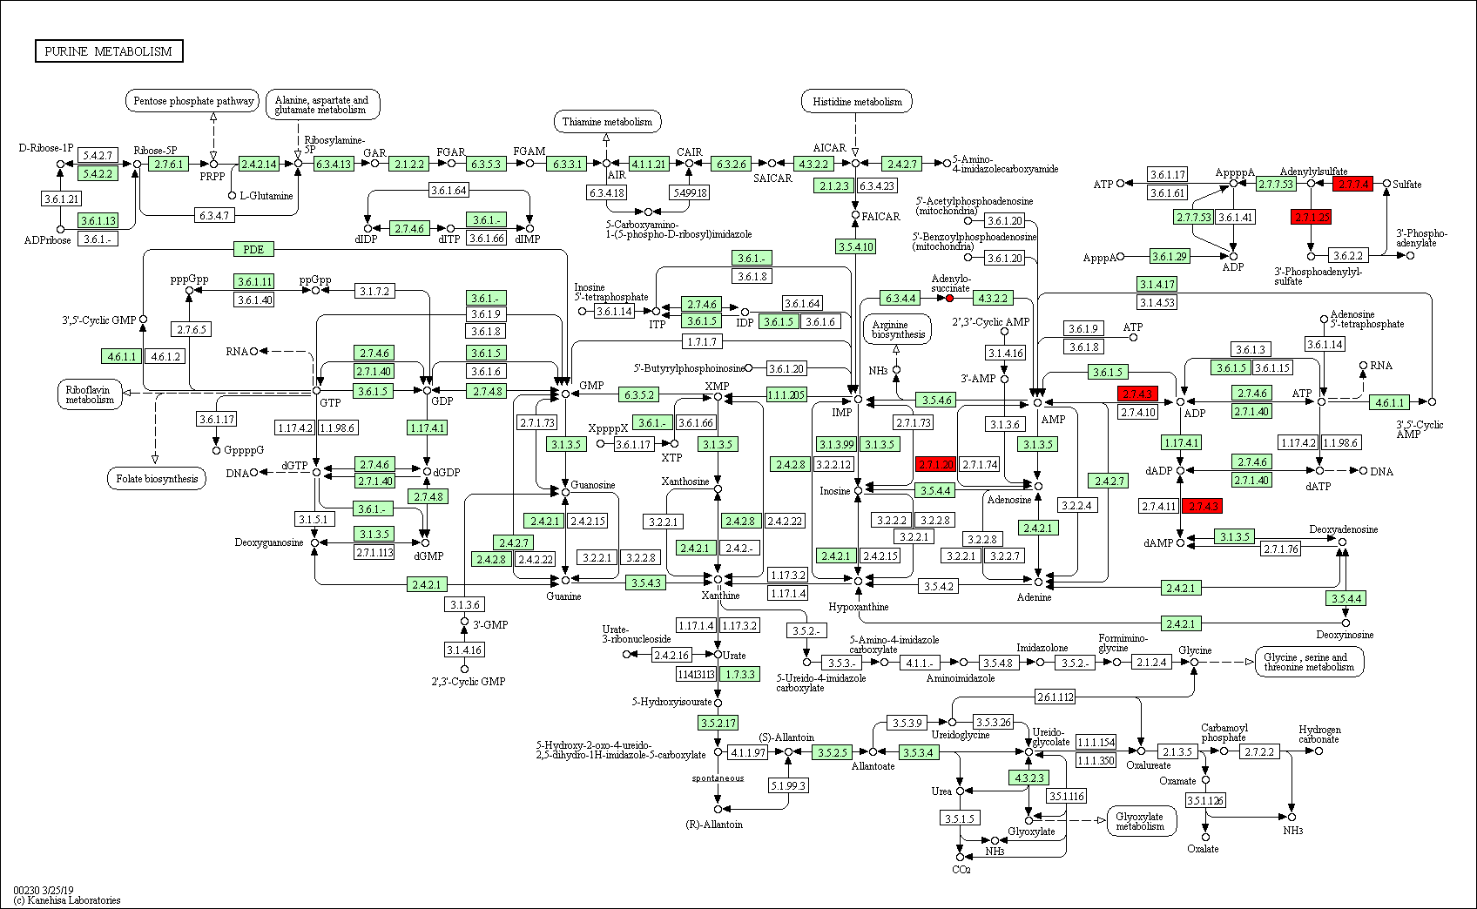

B
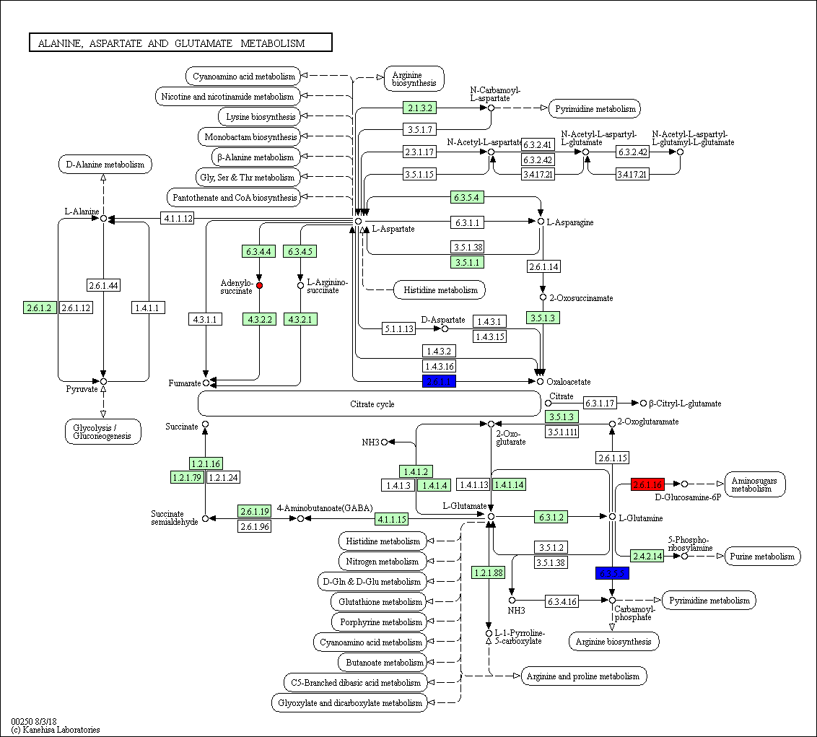
C
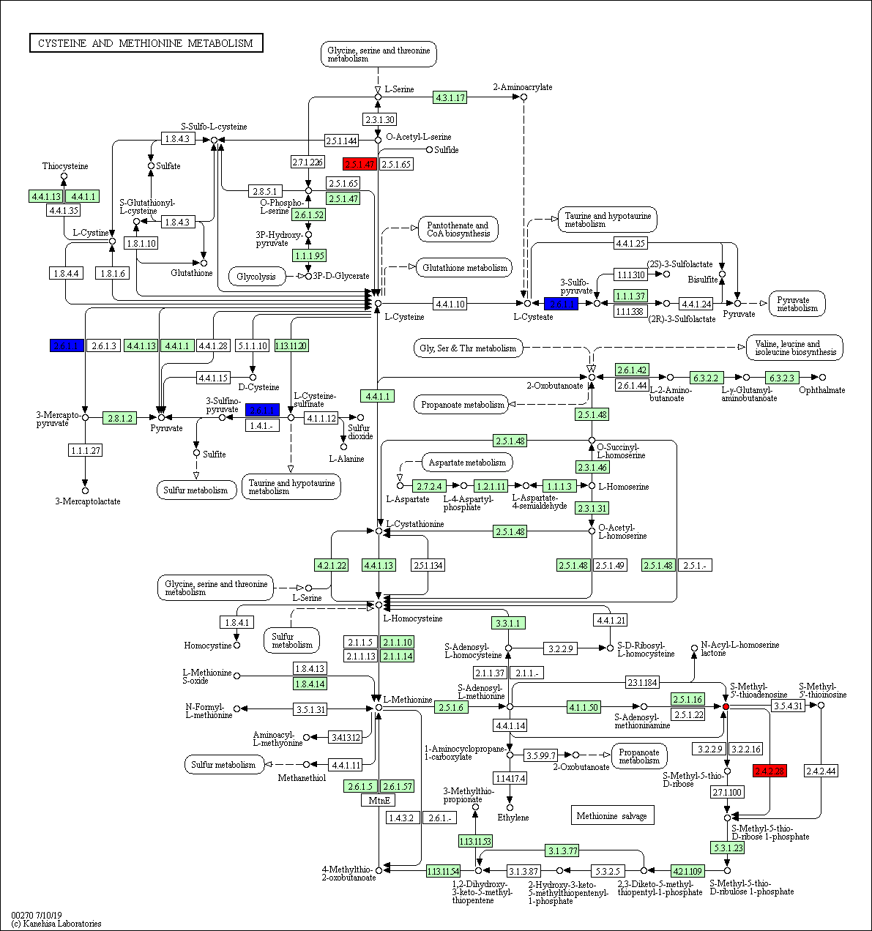

Figure S3. Integrated analysis of proteome and metabolome result on KEGG pathway. (A) Purine metabolism. (B) Alanine, aspartate glutamate metabolism. (C) Cysteine and methionine metabolism. Boxes represented for proteins and dots represented for chemical compounds. The red color represented proteins or metabolites that were up-regulated in spaceflight group. The blue color represented proteins or metabolites that were down-regulated in spaceflight group.

